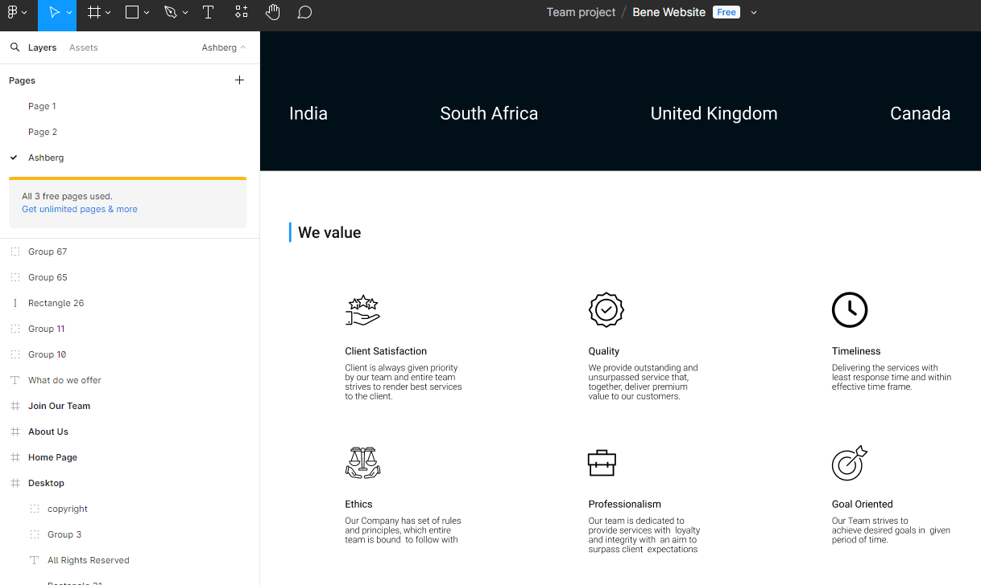
Client Satisfaction
Quality
Timeliness
Client is always given priority by our team and entire team strives to render best services
to the client.

We provide outstanding and
unsurpassed service that, together, deliver premium value to our customers.

Delivering the services with least response time and within
effective time frame.
Ethics
Professionalism
Goal Oriented
Our Company has set of rules
and principles, which entire team is bound to follow with
Our team is dedicated to
provide services with loyalty and integrity with an aim to surpass client expectations

Our Team strives to
achieve desired goals in given period of time.

https://scrapnews.recycleinme.com/newsdetails-623.aspx

Bene LLC Marketing Website Content

Home Page

Header:
• Logo
• Navigation Menu: Home, About Us, Metals, Agriculture, Careers, Contact Us, Sustainability

Hero Section:
• Background Image/Video of global trading and logistics
• Headline: Global Trading Across Diverse Commodities
Offering unparalleled sourcing and logistics, Bene LLC excels in providing worldwide sourcing and integrated supply chain solutions.

About Us Section:
• Brief introduction about Bene LLC
• Link to full About Us page

Our Services Section:
• Short descriptions of key services with icons: Sourcing, Logistics, Warehousing, Distribution
• Link to Solutions page

Why Choose Us Section:
• Highlights: Expertise, Global Reach, Sustainability
• Client testimonials

Footer:
• Contact Information
• Social Media Links (Twitter, LinkedIn, YouTube)
• Quick Links: About Us, What We Do, Products, Careers, Contact Us, Sustainability
• Copyright Information

About Us Page

Header:
• Page Title: About Us

Content:
• Introduction:
Bene is a renowned global trading company, excelling in the sourcing and trading of diverse commodities. With a proven track record spanning over five years, Bene has become a trusted partner for clients worldwide, offering unparalleled trading services and robust supply chain solutions.
• Our Expertise:
Our success is rooted in our expertise in providing competitive supply chain management, logistics, and trade solutions. Backed by a highly skilled team of professionals, we are dedicated to meeting the unique requirements of our clients efficiently and ensuring their utmost satisfaction.
• Our Services:
At Bene, we deliver end-to-end supply chain management, ensuring a seamless flow of commodities from their origins to their destinations. Leveraging our logistics proficiency, we optimize transportation and storage processes, driving cost reductions and maximizing operational efficiency.
• Our Values:
We adhere to the highest standards of responsible sourcing and sustainability, ensuring safe and secure supply chains.

Solutions Page

Header:
• Page Title: Our Solutions

Content:
• Integrated Supply Chain Services:
We specialize in offering tailored solutions based on your unique requirements, from a simple courier or freight shipment (by sea, air, pallet, or container), to more complex needs.
• Supply Chain Services:
- Integrated sourcing, logistics, and warehousing solutions
- Selling agent services
- Regular sourcing

Vision & Mission Page

Header:
• Page Title: Our Vision & Mission

Content:
• Vision:
To be the preferred global trading partner, providing exceptional value and reliability to our clients. We aspire to build strong relationships, leverage market insights, and deliver innovative solutions that drive growth and success in the ever-evolving world of international trade.
• Mission:
Our mission is to consistently exceed our clients’ expectations by offering a diverse portfolio of high-quality products, seamless supply chain solutions, and unparalleled customer service. We aim to establish ourselves as a trusted and reliable partner, fostering long-term relationships and contributing to the success of our clients’ businesses.

Contact Us Page

Header:
• Page Title: Contact Us

Content:
• Contact Information:
- Address: 762 GREEN ST, ISELIN, NJ, 08830 USA
- Email: info@benellc.com
• Contact Form:
- Fields: Name, Email, Phone, Message
- Submit Button
• Map:
Embedded Google Map showing the office location

Pages
• What We Do:
Detailed descriptions of the company's services and operations
• Products:
Information on the commodities and products traded
• Careers:
Job openings and application information
• Sustainability:
Initiatives and commitments towards sustainable practices

Design Considerations
• Visual Identity:
Use the company logo and a consistent color scheme that reflects professionalism and trust.
• User Experience:
Ensure the website is mobile-friendly, easy to navigate, and has fast loading times.

